Complete this summary chart the IP’s Classification Trajectory.

Click here for instructions how to find the Classification Scores, and for what should go into the table. Remember: Add the IP’s name to the header, your name to the footer, and a citation to the Bates-numbered page for EVERY fact you include!

Date | Placement Score | Cite
Classification Trajectory FAQs

- What is a Classification Trajectory?
IPs are assigned a classification score at least once a year. The classification score affects the IPs’ housing and degree of supervision. Looking at these scores over time can provide insight into the IP’s progress.
- Where can I find the Classification Scores?
In SOMS, go to “Classification Scoresheets” in the Table of Contents. You should find a document that looks like the image below. For each entry, add the date and placement score to this summary. The Score is just a number; no other information is necessary.
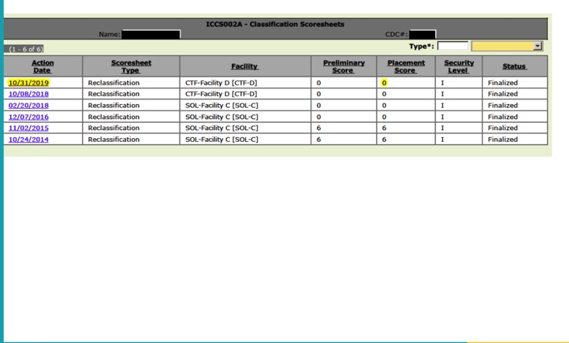

In ERMS, check for “Custody Classification – Assignments.” In these documents the placement score is referred to as a “class score.”

Keyword searches

Classification Scoresheets
Custody Classification
Placement Score
Class Score

