Complete this summary chart of all RVRs in reverse chronological order. For each individual RVR, complete a narrative report.
Click here for instructions on finding RVRs in the C-File, and for what should go into the summary and into the narrative report. Remember: Add the IP name to the header, your name to the footer, and always add a citation to the Bates-numbered page for EVERY fact you include.

RVR Summary Timeline
# | Incident Date | Facility | Rules Violation | Classi-fication | Finding | Disposition  (Sanction or Punishment) | Referral? | Cite
1
2
3
4
5
6
7
8
9
10
11
12
13
14
15
16
17
18

RVR Narrative Report
# | Incident Date | Facility | Rules Violation | Classi-fication | Finding | Disposition  (Sanction or Punishment) | Referral? | Cite
1
Narrative report of RVR

RVR Narrative Report
# | Incident Date | Facility | Rules Violation | Classi-fication | Finding |  | Disposition  (Sanction or Punishment) | Referral? | Cite
2
Narrative report of RVR

RVR Narrative Report
# | Incident Date | Facility | Rules Violation | Classi-fication Level | Finding | Disposition  (Sanction or Punishment) | Referral? | Cite
3
Narrative report of RVR

RVR Narrative Report
# | Incident Date | Facility | Rules Violation | Classi-fication Level | Finding | Disposition  (Sanction or Punishment) | Referral? | Cite
4
Narrative report of RVR

RVR Narrative Report
# | Incident Date | Facility | Rules Violation | Classi-fication Level | Finding | Disposition  (Sanction or Punishment) | Referral? | Cite
5
Narrative report of RVR

RVR Narrative Report
# | Incident Date | Facility | Rules Violation | Classi-fication Level | Finding | Disposition  (Sanction or Punishment) | Referral? | Cite
6
Narrative report of RVR

RVR Narrative Report
# | Incident Date | Facility | Rules Violation | Classi-fication Level | Finding | Disposition  (Sanction or Punishment) | Referral? | Cite
7
Narrative report of RVR

RVR Narrative Report
# | Incident Date | Facility | Rules Violation | Classi-fication Level | Finding | Disposition  (Sanction or Punishment) | Referral? | Cite
8
Narrative report of RVR

RVR Narrative Report
# | Incident Date | Facility | Rules Violation | Classi-fication Level | Finding | Disposition  (Sanction or Punishment) | Referral? | Cite
9
Narrative report of RVR

RVR Narrative Report
# | Incident Date | Facility | Rules Violation | Classi-fication Level | Finding | Disposition  (Sanction or Punishment) | Referral? | Cite
10
Narrative report of RVR

RVR Narrative Report
# | Incident Date | Facility | Rules Violation | Classi-fication Level | Finding | Disposition  (Sanction or Punishment) | Referral? | Cite
11
Narrative report of RVR

RVR Narrative Report
# | Incident Date | Facility | Rules Violation | Classi-fication Level | Finding | Disposition  (Sanction or Punishment) | Referral? | Cite
12
Narrative report of RVR

RVR Narrative Report
# | Incident Date | Facility | Rules Violation | Classi-fication Level | Finding | Disposition  (Sanction or Punishment) | Referral? | Cite
13
Narrative report of RVR

RVR Narrative Report
# | Incident Date | Facility | Rules Violation | Classi-fication Level | Finding | Disposition  (Sanction or Punishment) | Referral? | Cite
14
Narrative report of RVR

RVR Narrative Report
# | Incident Date | Facility | Rules Violation | Classi-fication Level | Finding | Disposition  (Sanction or Punishment) | Referral? | Cite
15
Narrative report of RVR

RVR Narrative Report
# | Incident Date | Facility | Rules Violation | Classi-fication Level | Finding | Disposition  (Sanction or Punishment) | Referral? | Cite
16
Narrative report of RVR

RVR Narrative Report
# | Incident Date | Facility | Rules Violation | Classi-fication Level | Finding | Disposition  (Sanction or Punishment) | Referral? | Cite
17
Narrative report of RVR

RVR Narrative Report
# | Incident Date | Facility | Rules Violation | Classi-fication Level | Finding | Disposition  (Sanction or Punishment) | Referral? | Cite
18
Narrative report of RVR

RVR Narrative Report
# | Incident Date | Facility | Rules Violation | Classi-fication Level | Finding | Disposition  (Sanction or Punishment) | Referral? | Cite
19
Narrative report of RVR

RVR Narrative Report
# | Incident Date | Facility | Rules Violation | Classi-fication Level | Finding | Disposition  (Sanction or Punishment) | Referral? | Cite
20
Narrative report of RVR

FAQ for Rules Violation Report Summary

- What is an RVR?

RVR is the prison’s written report of any adjudicated rules violation.

(back to top)

- How do I find them?
  - RVRs can be found in either ERMS or SOMS or both.
    - In SOMS, there should be a bookmarked section called “Disciplinary”
    - In ERMS, you will need to search for Keywords.
    - Check anywhere the Keywords show up so that you can confirm that no RVRs are missing from your summary.
  - Keyword searches
    - “Rules Violations Reports”
    - “RVR”
    - “Disciplinary”

(back to top)

- What should be in the summary chart?

  - For each RVR in SOMS, most of the information in the summary chart is listed just as requested here, and the remainder can be found in the Disposition section. Here is an example:

    - SOMS RVR Summary
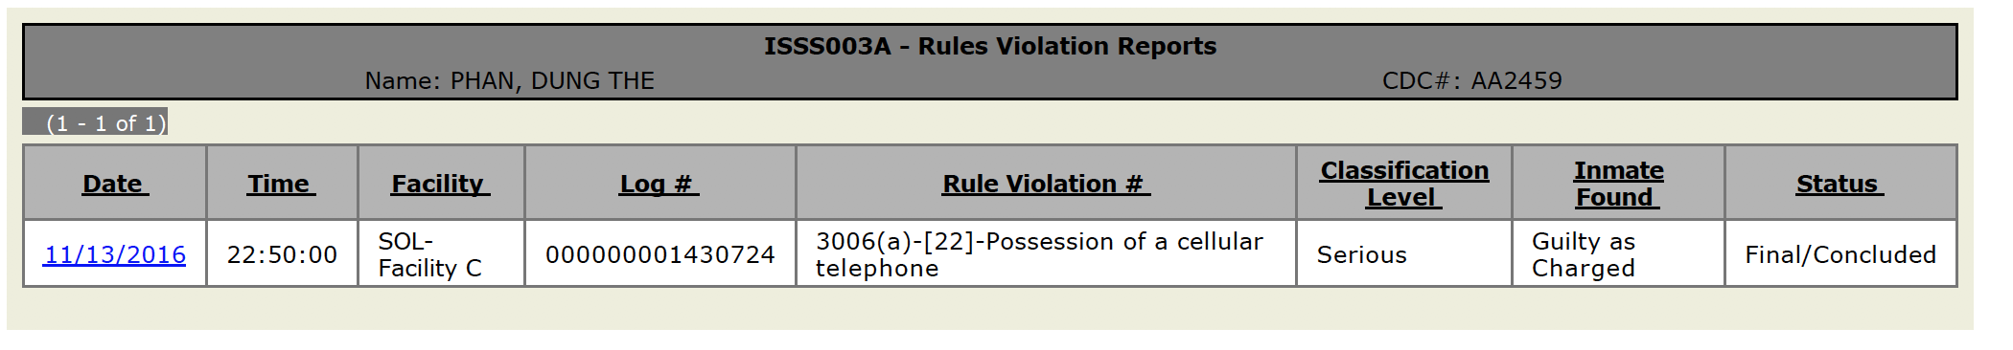
    - SOMS RVR Disposition

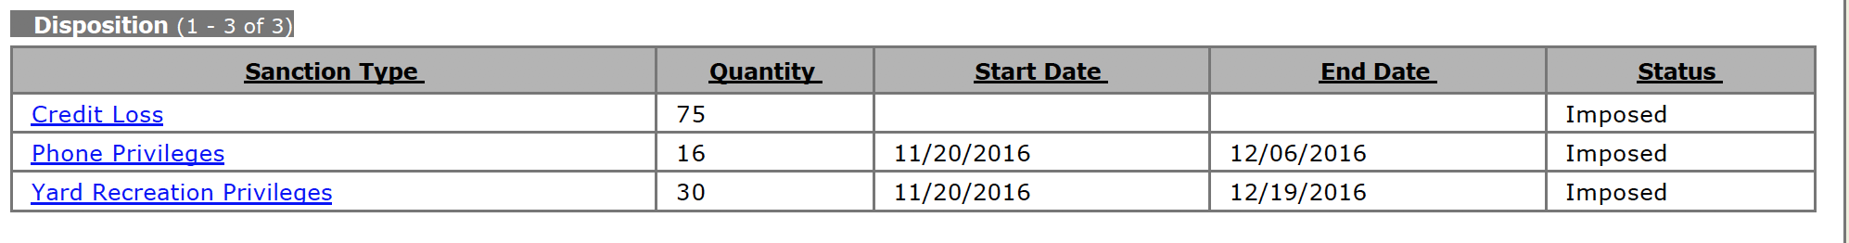

  - For reports in ERMS, you should be able to find the corresponding information, but it may be spread throughout the report, and may be in handwritten notes.
  - There will be multiple references to RVRs that will show up in keyword searches. Check those references to make sure that no RVRs are missing from your list.
  - Incident Date: This is the date of the alleged violation, not the date of the hearing or disposition.
  - Facility: This is the prison where the alleged violation occurred. Prisoners are frequently transferred, so it might not be where they are currently held.
  - Rules Violation: Include both the title of the violation and the rule or statute number. See SOMS example above. If the RVR is in ERMS, you will need to look for this info.
  - Classification: this indicates seriousness of the offense charged. In SOMS, this is clearly marked in the summary. In ERMS, you will need to find it.
  - Finding: this is the outcome of the proceedings, e.g. guilty as charged, guilty of other charge, not Guilty.

  - Disposition: this is the punishment received, if any. Include the type and amount.

  - Referral to DA or AG: If the rules violation is also a violation of law (e.g. an assault), the prison may decide to refer the matter to the District Attorney. If so, the referral will be in the file.
(back to top)

- What should be in the narrative report?

In the narrative, include the summary of the incident, the IP’s statement, the detailed findings, and any later changes in the resolution (e.g. if the punishment or severity was later amended).
- Keyword Searches

Rules Violation Report(s)
RVR, RVRs
Disciplin*
Inmate Assignment History
Offender Assessment(s)
(back to top)

